

Eye Discharge in Newborns
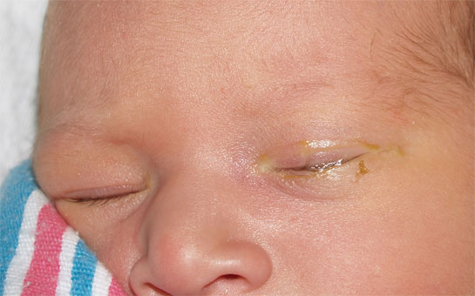
One of the most common questions I get from the parents of newborns is regarding the “goopy eye”. Often times one or both eyes will develop a yellowish to whitish thick discharge. This often begins about 2 weeks of age and may continue on and off for several months.
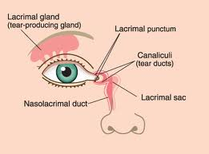
The cause of this is a narrowing or blockage of the nasolacrimal duct. The nasolacrimal duct is the small connection that drains our normal tears from the eyes to the nose. This is why we get a runny nose when we cry. You can see the opening of the nasolacrimal duct (the punctum) if you look in the mirror and gently pull down on your inner, lower lid. There is a small opening that drains to a small sac between your eye and nose and then eventually empties into the nose.
Because everything is small in newborn babies, the nasolacrimal duct often is narrow or even completely blocked. Babies make a minimal amount of tears initially and begin to increase tear production around 2 weeks of age. As a result, if the duct is narrow and doesn’t drain properly, the tears will have nowhere to go and will evaporate, leaving behind a sticky, yellowish goo. This is not an infection but rather the result of an anatomic issue. The eyelid may be minimally red from irritation but the eye itself shouldn’t be red or irritated. This doesn’t usually bother the baby, just the parents.
If the tears drain to the nasolacrimal sac without being able to fully empty, then the duct can get infected. If this happens, the discharge goes from being sticky and yellow to looking like thick green snot. When the discharge is wiped away, it will re-accumulate in a few minutes. If this happens, I usually prescribe and antibiotic eye drop or ointment that will fix the infection in a day or two.
The best way to manage the nasolacrimal duct obstruction is to gently massage the tear duct to help push the tears along their intended path and open up the narrowing. This is done by gently running your index finger along the side of the baby’s nose from just above the eye to just below it. You may see a small amount of tears or goo expressed from the opening of the nasolacrimal duct. This accomplishes two things. First, it helps to open the narrowed duct and fix the anatomic problem. Second and more importantly, it allows the sac full of tears to empty and thus prevents it from getting infected. Doing this consistently (every few diaper changes for instance) will minimize the need for antibiotic eye drops.

As the baby grows, so will the nasolacrimal duct. The duct narrowing does not go away overnight. As your child’s ducts grow in diameter and things seem to be improving, they may get a cold or other type of congestion that may make the eyes appear to be worse than they had been recently. The process takes some time to resolve.
In my experience, about a third of newborn babies have a blocked tear duct in one or both eyes. Of these, about half of them resolve by four months of age and three-quarters are better by six months of age. Ninety-nine percent of blocked nasolacrimal ducts are resolved by a year of age, so it is only one-percent of the babies (or one in 300) that need referral to an ophthalmologist at a year to have the duct opened with a probe. It is a benign procedure but requires general anesthesia so why fix something that in most cases, will resolve by itself?
The take-home messages are as follows:
- Goopy eyes are common in newborns and usually do not require medication.
- Gentle massage of the duct a few times a day will help resolve the problem and prevent infection.
- The blockage/narrowing usually takes several months to fully resolve so don’t expect it to go away in a week or two.
- The need for intervention by an ophthalmologist is very uncommon.
If your child’s eye’s seem red or if the discharge seems to bother them then come in for a visit. Blocked nasolacrimal ducts shouldn’t cause pain or redness. Of course if something doesn’t seem right, then call or make an appointment.
--Be Well

Drew Nash, M.D.

